SESION 1: K-NN Clasficication

1. Clasficication example

Set the work directory as: ./Ejemplo1.
We are going to check a previous dataset. Use the function:

>> Representar_Datos(‘data1.mat’);

Result should be similar or equal to:
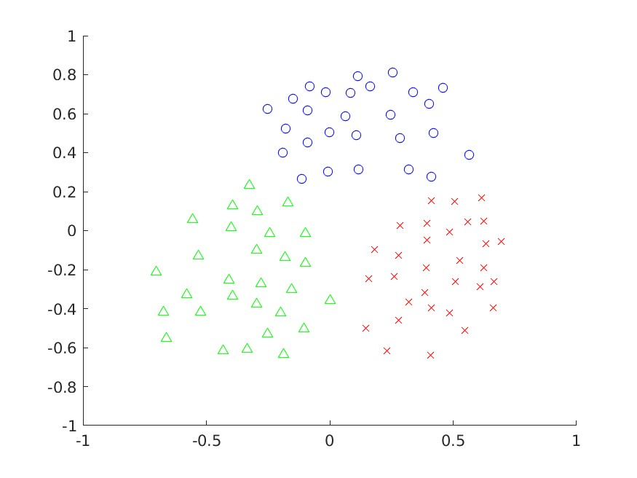

Data correspond to 87 training samples with dimension 2 from 3 different classes.

Check the K-NN clasification using:

>>Clasificar_Nueva_Muestra('data1.mat');

The training samples appear in different colors, click left mouse button to add a new sample to classify. The NN will be rounded and the selected class is showed.

Hit any key to repeat the experiment and test several samples near to the limits of the classes.

To finish click right mouse button and any key.

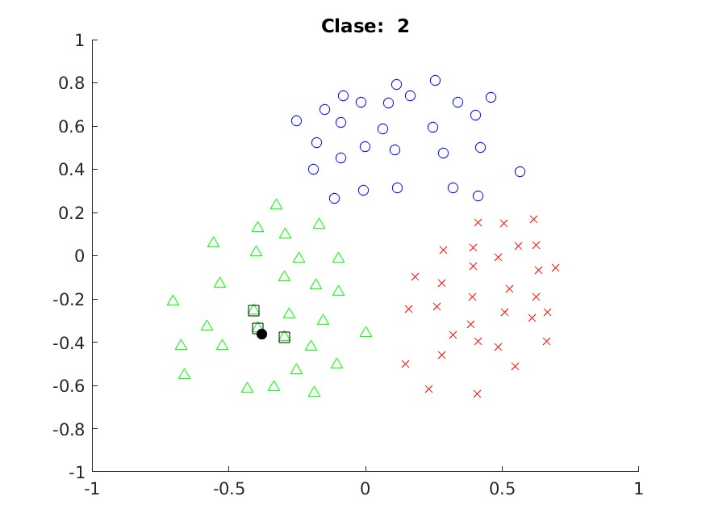

2. Your own example

Clean the figure and clear the variables using:
>> clf;
>> clear

Create your own training set using:

>>data=Obtener_Datos( );

Draw class 1 samples by clicking left mouse button.
Click on central mouse button to change for the next class ‘2’ and repeat the process until the 3rd class. Clicking ENTER and the end to finish.

Save the training set in a *.mat file
>> save p.mat data

Repeat the first experiment with this new data file.

3. Code modification.

Change the function Clasificar_Nueva_Muestra in order to consider a different number
of neighbour.

4. Data form images

Set work directory /Ejemplos2/ and run:

>> visualizar_datos

The results give:
ACC is the accuracy
CM confusion matrix

1. Repeat the experiment for 2, 3, 5 and 9 neighbour
2. Review the most probable errors for samples:0', '1', '2', '3', '4', y '5'.

Complete the table for 2,3,5 y 9 neighbour

Neighbout | Accuracy
2 | 0.9650
3 | 0.9620
5 | 0.9620
9 | 0.9450
20 | 0.9130

Paste the confusion matrix for 9 neighbor
